- Ask user to enter 10 numbers and find the largest, smallest, Average, and Sum of the entered numbers.
- Write a program to print all prime numbers from 1 to 300.
- Write a program in C to display the n terms of harmonic series and their sum. 1 + 1/2 + 1/3 + 1/4 + 1/5 ... 1/n terms
- Ask user to enter a decimal number and convert it to binary number format.
- Ask user to enter a binary number and show its decimal value.
- Write a program that uses for statements to print the following patterns separately, one below the other. Use for loops to generate the patterns. All asterisks (*) should be printed by a single statement of the form cout << '*'; (this causes the asterisks to print side by side). [Hint: The last two patterns require that each line begin with an appropriate number of blanks. Extra credit: Combine your code from the four separate problems into a single program that prints all four patterns side by side by making clever use of nested for loops.]
(a) (b) (c) (d)
* ********** ********** *
** ********* ********* **
*** ******** ******** ***
**** ******* ******* ****
***** ****** ****** *****
****** ***** ***** ******
******* **** **** *******
******** *** *** ********
********* ** ** *********
********** * * **********

- Write a program to print (up to n. Here n=5)
1
12
123
1234
12345

- Write a program to print a pyramid

*
***
*****
*******
*********

- Write a program to print

1
123
12345
1234567
123456789

- Write a program to print Diamond

*
***
*****
*******
*********
*******
*****
***
*
9. (Pythagorean Triples) A right triangle can have sides that are all integers. A set of three integer values for the sides of a right triangle is called a Pythagorean triple. These three sides must satisfy the relationship that the sum of the squares of two of the sides is equal to the square of the hypotenuse. Find all Pythagorean triples for side1, side2 and hypotenuse all no larger than 500. Use a triple-nested for loop that tries all possibilities. (a² + b² = c²)

- Write a program in C to print.
1
01
101
0101
10101

- Write a program to find the sum of following series.
$\frac{1}{1!}+ \frac{1}{2!}+ \frac{1}{3!}+ \frac{1}{4!}+ \frac{1}{5!}+ \frac{1}{6!}$

- Write the above program for n number (e.g., n=6 in above case)
- Write a program to generate all combinations of 1, 2 and 3 using for loop. (e.g., 111, 112, 113, 121, …..)
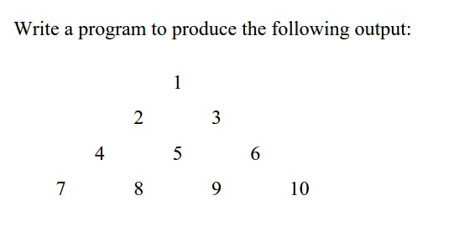

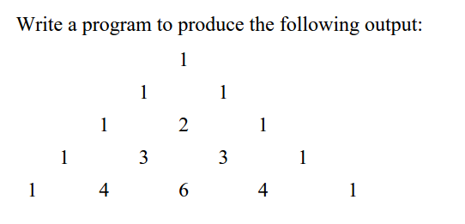

the entries in Pascal's Triangle are called the binomial coefficients. The rows are represented by n and columns by k. Always start with n=0 and k=0.

There's a pretty simple formula for figuring out the binomial coefficients:
n!
[n:k] = --------
k! (n-k)!
6 * 5 * 4 * 3 * 2 * 1
For example, [6:3] = ------------------------ = 20.
3 * 2 * 1 * 3 * 2 * 1

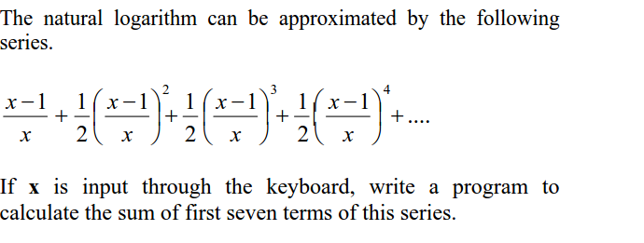

- check whether a number is a Strong Number or not. A number is strong when sum of factorial of its digits is equal to number itself. E.g., 145 (1! + 4! + 5! = 145)

